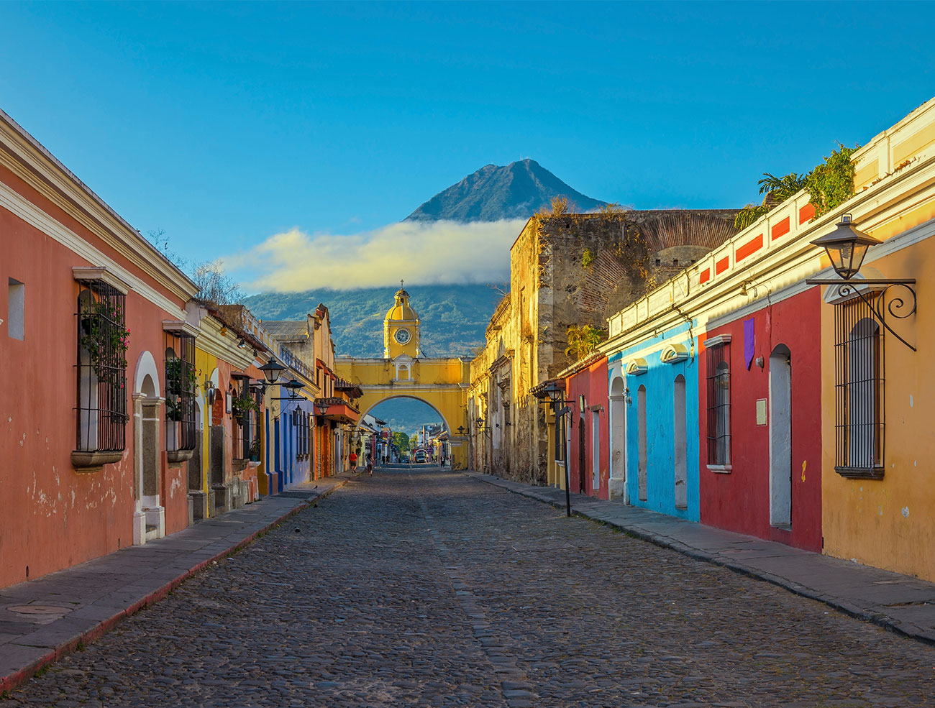
GUATEMALA HOMELAND TOUR REGISTRATION
Tour Dates: July 25th- August 2nd 2020

Complete this form and return to Barker along with a non-refundable deposit of $600 per person. Please make checks payable to: The Barker Adoption Foundation with Guat Trip 2020 in memo field.

FAMILY LAST NAME(S):

Address, City, State, Zip:

Home Phone #:

Parent Cell Phone #:

Parent Cell Phone #:

Parent E-mail:

Parent E-mail:

Participant 1
Print your complete name exactly as it appears on your Passport
(LAST, First, Middle)

Date of Birth (MM-DD-YYYY)

Age at time of Tour (age as of July 25, 2020)

Gender

Cell Phone #:

E-mail:

Passport #

Passport Expiration Date

Was this participant adopted through Barker? If not, what agency did you use in the U.S. ?

Please list any current medications, including dosage & reasons for taking:
Medication/Dosage | Reason
Please list any known medical conditions that are currently under treatment or being monitored:
Condition | Treatment

Please list current dietary restrictions or allergies to medications, food, insects, or other substances:

Please list any physical limitations that may limit participation in physical activities:

Please provide information about any psychiatric, psychological or counseling treatment in the last year:

Please describe any other major illnesses, surgeries, treatments, hospitalizations or conditions of any participating family members that we should be aware of:

Participant 2
Print your complete name exactly as it appears on your Passport
(LAST, First, Middle)

Date of Birth (MM-DD-YYYY)

Age at time of Tour (age as of July 25, 2020)

Gender

Cell Phone #:

E-mail:

Passport #

Passport Expiration Date

Was this participant adopted through Barker? If not, what agency did you use in the U.S.?
Please list any current medications, including dosage & reasons for taking:
Medication/Dosage | Reason

Please list any known medical conditions that are currently under treatment or being monitored:
Condition | Treatment

Please list current dietary restrictions or allergies to medications, food, insects, or other substances:

Please list any physical limitations that may limit participation in physical activities:

Please provide information about any psychiatric, psychological or counseling treatment in the last year:

Please describe any other major illnesses, surgeries, treatments, hospitalizations or conditions of any participating family members that we should be aware of:

Participant 3
Print your complete name exactly as it appears on your Passport
(LAST, First, Middle)

Date of Birth (MM-DD-YYYY)

Age at time of Tour (age as of July 25, 2020)

Gender

Cell Phone #:

E-mail:

Passport #

Passport Expiration Date

Was this participant adopted through Barker? If not, what agency did you use in the U.S.?

Please list any current medications, including dosage & reasons for taking:
Medication/Dosage | Reason

Please list any known medical conditions that are currently under treatment or being monitored:
Condition | Treatment

Please list current dietary restrictions or allergies to medications, food, insects, or other substances:

Please list any physical limitations that may limit participation in physical activities:

Please provide information about any psychiatric, psychological or counseling treatment in the last year:

Please describe any other major illnesses, surgeries, treatments, hospitalizations or conditions of any participating family members that we should be aware of:

Participant 4
Print your complete name exactly as it appears on your Passport
(LAST, First, Middle)

Date of Birth (MM-DD-YYYY)

Age at time of Tour (age as of July 25th, 2020)

Gender

Cell Phone #:

E-mail:

Passport #

Passport Expiration Date

Was this participant adopted through Barker? If not, what agency did you use in the U.S. ?

Please list any current medications, including dosage & reasons for taking:
Medication/Dosage | Reason

Please list any known medical conditions that are currently under treatment or being monitored:
Condition | Treatment

Please list current dietary restrictions or allergies to medications, food, insects, or other substances:

Please list any physical limitations that may limit participation in physical activities:

Please provide information about any psychiatric, psychological or counseling treatment in the last year:

Please describe any other major illnesses, surgeries, treatments, hospitalizations or conditions of any participating family members that we should be aware of:

Participant 5
Print your complete name exactly as it appears on your Passport
(LAST, First, Middle)

Date of Birth (MM-DD-YYYY)

Age at time of Tour (age as of July 25, 2020)

Gender

Cell Phone #:

E-mail:

Passport #

Passport Expiration Date

Was this participant adopted through Barker? If not, what agency did you use in the U.S.?

Please list any current medications, including dosage & reasons for taking:
Medication/Dosage | Reason

Please list any known medical conditions that are currently under treatment or being monitored:
Condition | Treatment

Please list current dietary restrictions or allergies to medications, food, insects, or other substances:

Please list any physical limitations that may limit participation in physical activities:

Please provide information about any psychiatric, psychological or counseling treatment in the last year:

Please describe any other major illnesses, surgeries, treatments, hospitalizations or conditions of any participating family members that we should be aware of:

In case of an emergency, please list a family member that is NOT participating in the tour:
Name: Relationship to you:

Address:

City: State: Zip:

Primary Phone Number

Alternative Phone Number

Second Alternative Phone Number

Please describe anything else you would like us to know about your family (ex. Are there other children traveling with you that are adopted from another country? Is this your child’s first visit? …etc)
LIABILITY RELEASE
In consideration of being allowed to participate in the 2020 Guatemala Homeland Tour (“the Homeland Tour”), sponsored by the Barker Adoption Foundation (“Barker”), the undersigned acknowledges and agrees to the following provisions of this release (the “Release”).
- I am aware of the risks of travel to and in Guatemala, including risks associated with my health, safety and security. I have read, or have had the opportunity to read, the United States Department of State’s Travel Alerts and Warnings for Guatemala, found at https://travel.state.gov/content/travel/en/international-travel/International-Travel-Country-Information-Pages/Guatemala.html. I also have read, or have had the opportunity to read, the information from the Centers for Disease Control and Prevention (“the CDC”) https://wwwnc.cdc.gov/travel/destinations/traveler/none/guatemala. I understand that the CDC recommends that I protect myself from mosquito bites.
- I am voluntarily participating in the Homeland Tour with a full understanding of these risks, and I assume and agree to accept all risks to my health, safety and security during the course of participating in the Homeland Tour. I acknowledge that, notwithstanding any travel or security arrangements made by Barker or any other party, Barker cannot guarantee my health, personal safety and property during or related to my participation in the Homeland Tour, including airline travel, ground transportation, meals, lodging, recreational activities and other activities, whether in Guatemala, the United States or any third country through which I may travel in connection with the Homeland Tour.
- In light of the above and in consideration of being permitted to participate in the Homeland Tour, I do, for myself, my spouse, my family, my heirs, my estate, my representatives, and my assigns, hereby release and hold harmless Barker from any and all liability, claims, or demands for damages that I presently have or may have in the future, arising out of any personal injury, emotional distress, bodily injury, sickness, death, loss of property, property damage, or any other loss, costs or expenses incurred by me or any family members, during the course of, as the result of, or in any way connected with my participation in the Homeland Tour, whether such damages, costs, or expenses arise out of the negligence of Barker or otherwise.
- This release extends, without limitation, to all travel in any way connected with the Homeland Tour - including all travel to and within any foreign country, and any and all connections, stopovers, transfers, and domestic portions of such travel - as well as all other activities in any way connected with the Homeland Tour.
- This release extends to and includes all trustees, employees, agents, contractors, representatives, successors, assignees, sponsors, volunteers, associates, and insurers of Barker; to all other persons and entities subject to liability derived from the conduct of Barker; and to any vicarious liability of Barker based on the conduct of any other person or entity (collectively, “the Releasees”).
- I understand that Barker does not provide insurance covering trip cancellation, dental or medical care while I am on the Homeland Tour. I further understand that Barker does not have any coverage for accidental injury and that Barker is not responsible for medical or evacuation costs. Accordingly, I understand that Barker strongly recommends that I purchase travel insurance that provides coverage for cancelled flights, medical and dental care abroad, accidental injury and, if necessary, medical evacuation. Here is an example of a Travel Insurance Company many families have recommended- Travelex Insurance. https://www.travelexinsurance.com/?gclid=Cj0KCQjwkK_qBRD8ARIsAOteukAmzHfdylKSbKMRnuni4RnIyidWXyHzOYifjZ8vkSDse0-Yfy4tx_saAlrXEALw_wcB
I have had a recent medical examination, or otherwise have good reason to believe that I am physically and mentally fit and capable to participate in the Homeland Tour. In the event I experience any injury, incapacity or illness during the Homeland Tour and am unable to consent to treatment due to physical, mental or other incapacity, Barker will use its reasonable, best efforts to contact my emergency contact as soon as practicable. However, if Barker is unable to communicate with the contact, or in case of an emergency, I authorize Barker to consent to medical treatment on my behalf. To the extent not covered by my insurance, I agree to pay all charges for such treatment and to reimburse or indemnify and hold Barker harmless therefrom.
- Any and all claims against the Releasees, whether arising in contract, tort or any other body of law arising under or relating in any manner to my participation in the Homeland Tour, shall be brought only in the federal or state courts of Maryland.
- The construction and application of this Release shall be governed by the laws of the state of Maryland, without regard to Maryland’s conflict of law principles.
- This Release contains the entire agreement between the parties to this Release. The Release supersedes any prior or contemporaneous agreements, understandings and negotiations regarding its subject matter.
- If any provision of this Release is held invalid, the remainder shall continue in full force and legal effect.
______________ _________________________________________
Date Signature of participant in Homeland Tour or parent or guardian of Same Below Age of 18
__________________________________________
Printed name of signatory
______________ _________________________________________
Date Signature of participant in Homeland Tour or parent or guardian of Same Below Age of 18 __________________________________________
Printed name of signatory
The Barker Adoption Foundation Colombia Homeland Tour
Policy on Alcohol and Drug Use

All family members participating in the tour agree to the following:
- Participants under 21 years old may not engage in drinking of any alcoholic beverages while on the trip; this is for both official trip outings as well as when not participating in official trip outings or activities.
- There will be no alcohol served or allowed at “official” Barker meals or gatherings, for parents or teens alike.
- There can be no use of any illegal substances and drugs while on the trip; any participant found to be using any illegal substances will be asked to leave the program.

I/We have read and understand the above policy, and agree to comply with it throughout the Guatemala Homeland Tour.

________________________ _____________________
Signature Date

________________________ _____________________
Signature Date

________________________ _____________________
Signature Date

________________________ _____________________
Signature Date

________________________ _____________________
Signature Date

The Barker Adoption Foundation
Photographic / Media Consent Form

I hereby consent to the use of my personal image(s) in select photos by The Barker Adoption Foundation as follows:
_____ on the new Barker Adoption Foundation website
_____ within Barker social media sites (Facebook, Twitter, LinkedIn, Instagram primarily)
_____ within newsletters/emails to people who have asked to stay informed about Barker
_____ within Barker brochures and/or publications issued to promote the work of Barker

I understand that my consent can be withdrawn in writing to Sue Hollar at shollar@barkerfoundation.org

CONSENT

I, ______________________________________________________,
Name of person giving consent & parent/guardian if under 18 years of age

I acknowledge these may be used as I have authorized above on media that promotes the work of The Barker Adoption Foundation. I understand that ultimately design preferences will determine if Barker uses the images I have authorized.

I further understand that this consent may be withdrawn by me at any time, upon written notice.
I give this consent voluntarily.

______________________________________ ______________________________________
Printed Name of person giving consent Signature of person giving consent
(parent/guardian < 18) (parent/guardian < 18)

______________________________________ ______________________________________
Printed Name of person giving consent Signature of person giving consent
(parent/guardian < 18) (parent/guardian < 18)
______________________________________ ______________________________________
Printed Name of person giving consent Signature of person giving consent
(parent/guardian < 18) (parent/guardian < 18)

Date ______________________________________

